Breast Cancer Stage Classification with miRNA

Project Members - Group #44
Joshua Adegboyo: jadegboyo2023@fau.edu (Team Lead)
Anika Baro Villa: abarovilla2021@fau.edu
Nicholas Campos: ncampos2022@fau.edu
Brehon Parker: bparker2012@fau.edu

Advisors/Sponsors
Dr. Ali Ibrahim: aibrahim2014@fau.edu
Dr. Hanqi Zhuang: zhuang@fau.edu

FAU Department of Electrical Engineering and Computer Science
Fall 2025

Project Summary
This project develops a breast cancer stage classification system using miRNA expression profiles from TCGA. It compares machine learning and deep learning models to identify the most effective approach. Feature selection aids biomarker discovery, ensuring clinical relevance.
Table of Contents
Introduction 3
1.1 Problem Description 3
1.2 Significance of the Problem 3
1.3 Literature Review 4
Proposed Solution 5
2.1 System Requirements 6
2.2 System Design 8
2.2.1 UML System Diagram 8
2.2.2 UML State Diagram 9
2.3 Subsystem Design and Implementation 10
2.3.1 Training Data Subsystem – Anika Baro Villa 10
2.3.2 Model Subsystem – Nicholas Campos 11
2.3.3 Model Explainability Subsystem – Joshua Adegboyo 11
2.3.4 Model Interface Subsystem – Brehon Parker 12
Implementation 13
3.1 Implementation Details 13
3.2 Test Plan 13
3.2.1 Data Partitioning and Evaluation Protocol 14
3.2.2 Use-Case Scenarios and Test Cases 14
3.2.3 Subsystem Testing 16
3.2.4 Integration Testing 17
3.2.5 Reproducibility and Deployment 17
Project Schedule and Timeline 18
4.1 Project Plan 18
4.2 Work Breakdown Structure (WBS) 19
4.3 Summary of Completed Tasks and Sub-Tasks 20
4.4 Detailed Task Breakdown and Member Responsibilities 21
4.5 Organizational Chart 32
4.5 Budget 32
References 33

Introduction

1.1 Problem Description
Breast cancer remains one of the most prevalent and life-threatening diseases among women globally. Accurate staging of breast cancer is essential, as it determines the treatment strategy and is strongly correlated with patient survival outcomes. However, traditional diagnostic methods can be invasive, expensive, or limited in their precision. MicroRNAs (miRNAs) are small, non-coding RNA molecules which have emerged as promising biomarkers due to their regulatory role in gene expression and their stability in biological samples. The challenge lies in effectively analyzing high-dimensional miRNA expression data to extract meaningful patterns that distinguish between cancer stages. Leveraging machine learning and deep learning models can provide a powerful, non-invasive, and automated tool to support clinicians in accurately staging breast cancer. This not only aids in personalized treatment planning but also contributes to ongoing research in cancer genomics and biomarker discovery.

1.2 Significance of the Problem
Addressing the challenge of accurately classifying breast cancer stages using miRNA expression data is crucial for several reasons. Firstly, breast cancer is a leading cause of cancer-related deaths among women worldwide. Early and precise identification of the cancer stage is essential for determining treatment options and improving patient outcomes. Misclassification or delays in staging can lead to under-treatment or over-treatment, both of which have serious health and economic implications.
An effective solution benefits a wide range of stakeholders:
- Patients: Improved stage classification can lead to timely and personalized treatment plans, increasing the chances of survival and quality of life.
- Clinicians and Oncologists: A reliable, automated tool can support decision-making, reduce diagnostic errors, and streamline workflow in high-volume clinical environments.
- Researchers: Identifying important miRNAs for cancer staging contributes to the broader scientific understanding of breast cancer biology, which may lead to novel biomarker discoveries.
- Healthcare Systems: Early and accurate staging can reduce the overall cost burden by avoiding unnecessary treatments and hospitalizations.
Although there are existing diagnostic and staging methods such as biopsies, imaging, and histopathological analysis, these approaches are often invasive, time-consuming, and prone to inter-observer variability. Some computational models exist for breast cancer classification using gene or miRNA data, but many suffer from limited accuracy, poor generalizability, and lack of interpretability due to high-dimensional data and small sample sizes. Furthermore, many models do not follow standardized data preprocessing workflows, making them less reproducible or clinically relevant.
This project aims to overcome these issues by leveraging both traditional machine learning and deep learning techniques on TCGA-standardized miRNA expression data to build a robust, interpretable, and clinically useful cancer staging tool.

1.3 Literature Review
Breast cancer remains a leading cause of cancer-related deaths among women, and accurate staging is essential for treatment planning and prognosis. In recent years, microRNAs (miRNAs) have gained attention as promising non-invasive biomarkers for cancer detection and classification due to their stability in biological samples and strong association with tumor progression.
Several studies have explored the application of machine learning models on miRNA expression data for breast cancer classification. For example, Zhang et al. investigated the use of support vector machines (SVM) to distinguish between early-stage and late-stage breast cancer using specific miRNA signatures, such as miR-21 and miR-155 [1]. Their results showed moderate accuracy, highlighting the potential of miRNA-based staging but also the need for more complex models to improve performance.
Peng et al. applied random forest classifiers to TCGA miRNA datasets to identify stage-specific miRNAs [2]. They emphasized the importance of feature selection in reducing dimensionality but also acknowledged limitations due to class imbalance, particularly with fewer Stage IV cases, an issue that can bias model training and evaluation.
Deep learning has also been explored in this field. Li et al. demonstrated that feedforward neural networks trained on both miRNA and mRNA expression data could outperform traditional machine learning models in classifying breast cancer subtypes [3]. While accuracy improved, interpretability remained a challenge, as the models acted as "black boxes" without clear biological insight into the learned features.
Another study by Liu et al. introduced a convolutional neural network (CNN) architecture that used heatmap representations of gene expression for cancer stage prediction [4]. Although the model showed strong performance, it relied on complex data transformation and lacked clinical reproducibility, limiting its practical adoption.
Beyond individual studies, tools such as miRWalk, miRDB, and CancerMIRNome offer resources for exploring miRNA-cancer relationships. However, these platforms primarily focus on binary classification (cancer vs. non-cancer) or subtype prediction, with limited support for detailed stage classification. Furthermore, they often do not implement integrated machine learning pipelines for preprocessing, training, and evaluation using standardized workflows like those provided by TCGA.
Collectively, these findings highlight both the promise and limitations of existing approaches. While previous work demonstrates the feasibility of using miRNA data for breast cancer classification, there remains a significant gap in tools that can accurately classify stages I–IV using a standardized and interpretable approach. This project aims to bridge that gap by developing a robust, reproducible machine learning system that integrates both traditional and deep learning techniques on well-curated TCGA datasets.

Proposed Solution
This project develops a comprehensive machine learning system for breast cancer stage classification using miRNA expression data from The Cancer Genome Atlas (TCGA) databases. The proposed solution addresses the critical need for accurate, automated breast cancer staging by leveraging the diagnostic potential of microRNA (miRNA) expression profiles, which have emerged as promising biomarkers for breast cancer classification and prognosis prediction.
The core innovation of our approach lies in implementing a systematic training/validation/testing framework that prevents data leakage while conducting rigorous comparative analysis between traditional machine learning and deep learning methodologies for classifying breast cancer stages (I-IV). Unlike previous studies that may suffer from methodological inconsistencies or data leakage issues, our system enforces strict data isolation protocols with stratified data splitting (70% training, 15% validation, 15% test) to ensure unbiased model evaluation and statistically valid conclusions.
Our solution strategy encompasses four key technical contributions: (1) systematic data management with preprocessing parameter consistency across all data partitions, (2) parallel implementation of traditional ML baselines (Support Vector Machines, Random Forest) and deep learning architectures (feedforward neural networks) using identical preprocessed datasets, (3) validation-based hyperparameter optimization and model selection without test data contamination, and (4) comprehensive statistical comparison framework with significance testing to determine the practical effectiveness of deep learning approaches over traditional methods.
The system emphasizes rigorous data management, feature selection, and statistical validation to identify important miRNA biomarkers while demonstrating improved classification performance through deep learning methodologies. By maintaining complete separation between training, validation, and test phases, our approach ensures that performance improvements are genuine rather than artifacts of data leakage, addressing a common pitfall in biomedical machine learning research. The resulting system provides not only accurate breast cancer stage classification but also interpretable insights into which miRNA features drive classification decisions, supporting both research advancement and potential clinical applications.

2.1 System Requirements
Table 1 outlines the functional requirements of the system. Each item defines a capability the software must support for effective miRNA‑based breast cancer stage classification and sets expectations for how the system should behave under different operating conditions.

Functional Requirements
F.1 | The system shall load TCGA Project breast cancer data including RNA sequencing results and clinical stage information.
F.2 | The system shall process miRNA quantitative information extracted from RNA sequencing data for individual patient cases.
F.3 | The system shall integrate clinical data to extract stage information (I, II, III, IV) and match case ID miRNA files with corresponding stage numbers.
F.4 | The system shall preprocess miRNA expression data using log₂(x + 1) transformation and standardization following the established workflow.
F.5 | The system shall implement labeling procedures to create supervised learning datasets for 4-class stage classification.
F.6 | The system shall perform feature selection to identify the most relevant miRNA biomarkers for breast cancer stage classification.
F.7 | The system shall train baseline machine learning models (SVM, Random Forest) using selected features for stage classification.
F.8 | The system shall implement multiple feedforward neural network architectures using Keras framework for improved classification.
F.9 | The system shall conduct performance comparisons between traditional ML baseline and deep learning approaches.
F.10 | The system shall generate comprehensive reports including model performance metrics, feature importance analysis, and classification results.
Table 1: Functional Requirements

Table 2 presents the non-functional requirements, which define quality attributes and performance constraints of the system. These focus on how the system operates, ensuring accuracy, reproducibility, usability, and efficiency.
Non-Functional Requirements
NF.1 | The system shall achieve classification accuracy exceeding baseline traditional machine learning performance on breast cancer stage classification.
NF.2 | The system shall complete the full workflow from data loading through final classification within reasonable research timeframes.
NF.3 | The system shall provide reproducible results with consistent methodology following the TCGA data processing pipeline.
NF.4 | The system shall be implemented using Python with scikit-learn for traditional ML and TensorFlow/Keras for deep learning components.
NF.5 | The system shall include visualization capabilities for presenting workflow results and model comparisons.
NF.6 | The system shall maintain detailed logs of the entire data processing and classification pipeline.
NF.7 | The system shall be executable on standard university computing resources with appropriate memory and processing capabilities.
Table 2: Non-Functional Requirements

Table 3 shows the safety requirements of the system. These requirements define constraints and behaviors of the system that must be met to protect the quality of users and minimize the risk of introducing unauthorized biases into the system.
Safety Requirements
S.1 | The system shall not store associations of data with personal information about the source to protect patient privacy.
S.2 | The classification model shall utilize unbiased, repeatable data to prevent introducing demographic or clinical biases into the system.
S.3 | The system shall include disclaimers about medical advice, clearly stating that classifications are for research purposes only and not intended for direct clinical diagnosis.
Table 3: Safety Requirements

2.2 System Design

2.2.1 UML System Diagram
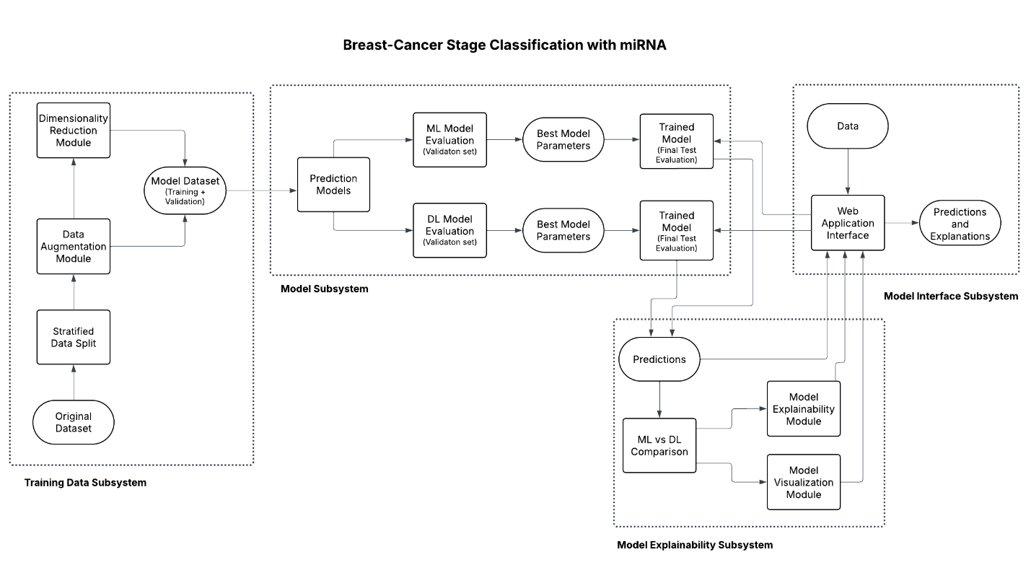
Figure 1: UML Activity Diagram (system-level view of the data pipeline)
Figure 1 presents a high-level UML activity diagram that organizes the pipeline into four subsystems: Training Data, Model, Model Interface, and Model Explainability. The system is based around the feasibility of using both traditional machine learning (ML) and deep learning (DL) models to classify breast cancer stages using miRNA expression data.
The training data subsystem processes TCGA miRNA data through augmentation and dimensionality reduction, followed by stratified data splitting (70/15/15) to ensure balanced representation of breast cancer stages across training, validation, and test sets, creating datasets suitable for systematic model training.
The model subsystem implements parallel training paths for baseline ML models (SVM, Random Forest) and DL models (Neural Networks, CNNs) with individual evaluation components using validation data for hyperparameter optimization and model selection, while maintaining test data isolation to prevent data leakage. After training, the best model architectures are integrated within the model interface subsystem, which includes the ML vs DL comparison module for statistical analysis and final test evaluation performed once on the held-out test set.
The interface subsystem uses predictions and model behavior to create visualizations and explanations, while the web application allows researchers to upload data, execute classifications with both approaches, and access comparative results demonstrating deep learning effectiveness versus traditional ML for breast cancer stage classification. Additionally, the Model Explainability subsystem ingests the raw predictions to perform ML vs. DL comparative analyses and produce interpretability outputs, such as feature importance explanations and interactive visualizations, to help researchers understand and trust the classification results.

2.2.2 UML State Diagram
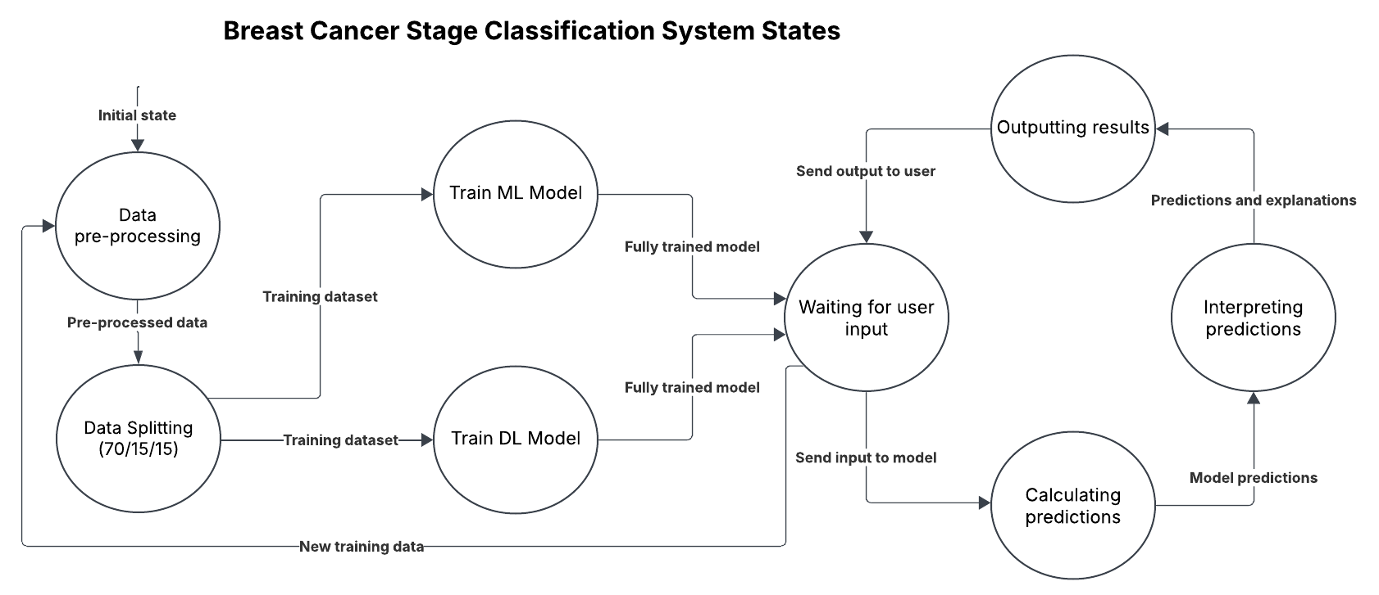Figure 2: UML State Diagram showing system state, from data pre-processing through model training, prediction, interpretation, and output
As shown in Figure 2, the state diagram illustrates the system's operational workflow across eight distinct states. The process begins in the "Data pre-processing" state where TCGA miRNA data undergoes standardization and feature preparation. Following preprocessing, the system transitions to the "Data Splitting 70/15/15" state, which implements stratified data partitioning to ensure balanced representation of breast cancer stages across training, validation, and test sets while preventing data leakage.
The key innovation appears in the parallel training states: "Train ML Model" and "Train DL Model" operate simultaneously after data splitting completion, demonstrating the comparative methodology that distinguishes this project. Both training processes use identical training datasets with systematic validation-based hyperparameter optimization to ensure fair performance comparison while maintaining test data isolation. After training completion, both paths converge at the "Waiting for user input" state, where the system maintains the best-selected models ready for classification requests. User interactions flow through "Calculating predictions" and "Interpreting predictions" states before reaching "Outputting results." The system includes a feedback loop allowing retraining with new data, supporting iterative research workflows typical in academic environments.

2.3 Subsystem Design and Implementation

2.3.1 Training Data Subsystem – Anika Baro Villa
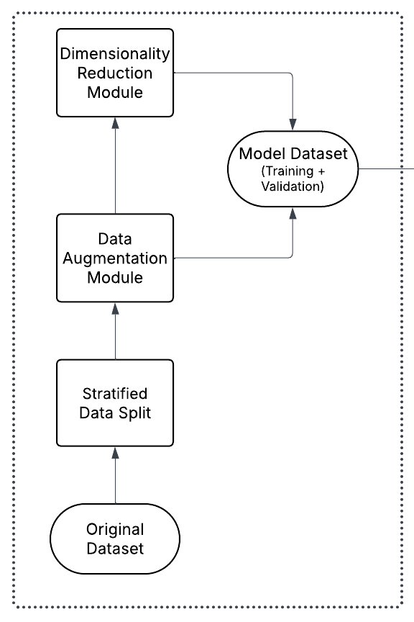
Figure 3: UML Activity Diagram of Training Data Subsystem
The Training Data Subsystem, depicted in Figure 3, handles the complete preprocessing pipeline required to prepare high-quality miRNA expression data for classification tasks. It starts by importing raw datasets from the TCGA portal, which include miRNA expression profiles and clinical staging information for breast cancer patients.
The Original Dataset Integration Module ensures case-ID consistency between expression data and staging labels, forming a clean and labeled dataset for supervised learning.
The Stratified Data Split Module partitions the dataset into training (70%), validation (15%), and testing (15%) subsets while preserving the distribution of breast cancer stages (I–IV). Preprocessing steps are applied only to the training data and then consistently reused on the validation and test sets to prevent data leakage, in line with best practices outlined in the FDA’s Artificial Intelligence and Machine Learning Discussion Paper [5].
Next, the Data Augmentation Module applies log₂(x + 1) normalization to reduce skewness in expression values, removes outliers, and validates sample quality to improve model robustness.
The Dimensionality Reduction Module then addresses the high dimensionality of miRNA data using statistical feature selection—such as mutual information, variance filtering, and correlation analysis—to retain only the most informative biomarkers for classification.
Finally, the cleaned, transformed, and reduced dataset is passed on for model training and evaluation.

2.3.2 Model Subsystem – Nicholas Campos
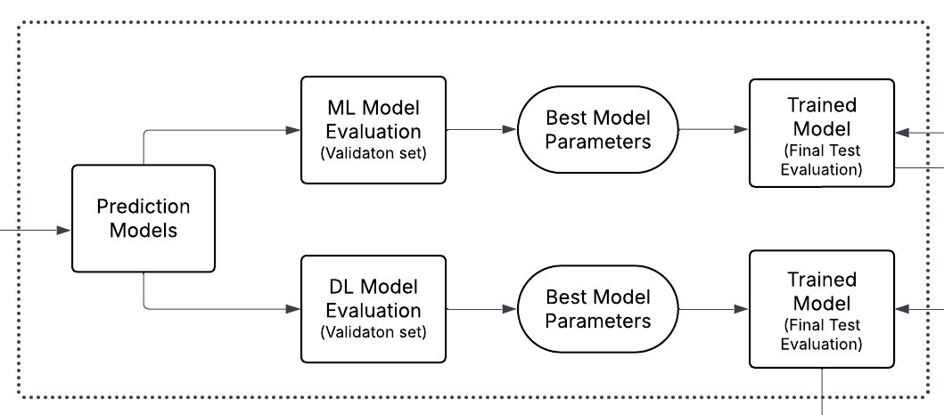
Figure 4: UML Activity Diagram of Model Subsystem
Figure 4 shows the Model Subsystem, which implements the project’s core comparative methodology by running parallel machine learning workflows. This design represents the main technical contribution of the system. The Prediction Models component manages dual training pathways: baseline ML using Support Vector Machines and Random Forest classifiers with scikit-learn, and deep learning using TensorFlow/Keras implementing feedforward neural networks and 1D CNNs for miRNA pattern detection.
Model Evaluation components assess performance, using validation data for hyperparameter optimization and model selection, with consistent cross-validation metrics across both approaches, including accuracy, precision, recall, and F1-score calculations for 4-class staging classification while maintaining test data isolation until final evaluation to prevent data leakage and ensure unbiased performance assessment. Best Model Parameters and Trained Model components handle optimization through hyperparameter tuning exploring optimizers, dropout rates, and batch sizes for deep learning models while maintaining baseline configurations for traditional ML. The parallel evaluation feeds into validation-based model selection and statistical significance testing that validates observed performance improvements and determines the most effective approach for breast cancer stage classification using miRNA biomarkers.

2.3.3 Model Explainability Subsystem – Joshua Adegboyo
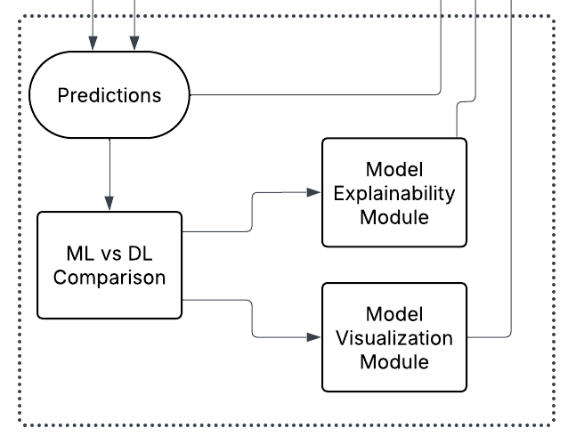
Figure 5: UML Activity Diagram of Explainability Subsystem
Figure 5 presents the Model Explainability Subsystem, which is responsible for creating information that expands upon the results from both ML and DL models to provide meaning and context to miRNA classification results. This subsystem analyzes model predictions to help researchers understand which miRNA features drive stage classification decisions in both approaches, comparing current predictions with previous data to reveal trends specific to breast cancer staging. The Model Visualization Module creates relevant visualizations and graphs to aid with interpreting the comparative results and enhance user experience. Feature importance analysis identifies critical miRNA biomarkers for each model type, while model behavior explanations help researchers understand performance differences between approaches.

2.3.4 Model Interface Subsystem – Brehon Parker
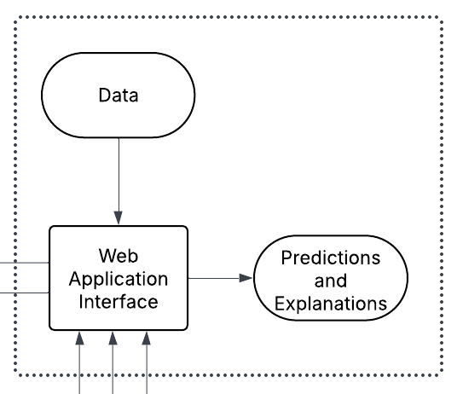
Figure 6: UML Activity Diagram of Interface Subsystem
As illustrated in Figure 6, the Model Interface Subsystem handles result analysis, comparison, and presentation to research users, transforming raw model outputs into meaningful insights for academic interpretation. The ML vs DL Comparison Module performs critical comparative analysis implementing statistical testing to determine the significance of performance differences between approaches, including confidence intervals and effect sizes beyond simple accuracy comparisons.
The Web Application Interface serves as the primary user interaction platform, allowing researchers to upload miRNA data, execute classifications with both model types, and access comparative results with data validation, progress tracking, and export capabilities necessary for research workflows. Data and Predictions and Explanations components manage information flow from trained models through the interface system, handling batch processing capabilities and maintaining prediction history for analysis while ensuring data integrity throughout the classification pipeline.

Implementation
This section presents the practical approach to implementing the breast cancer stage classification system using miRNA expression data, with a focus on the selected technologies, development environments, and integration methods that will support the system. Subsystem functionality and design considerations are discussed in Section 2 (Proposed Solution).

3.1 Implementation Details
This project proposes the development of a breast cancer stage classification system using Python and well-established machine learning and deep learning libraries. Traditional models, such as Support Vector Machines (SVM) and Random Forest, will be built with scikit-learn, while deep learning models—including multi-layer perceptrons (MLP) and one-dimensional convolutional neural networks (1D CNN)—will be implemented using TensorFlow and Keras. All model training and testing will be carried out using interactive coding environments such as Jupyter Notebooks and Google Colab, to aid reproducibility and collaboration across the team. GitHub will be used for version control throughout the development process.
The data will be manually downloaded from The Cancer Genome Atlas (TCGA) Genomic Data Commons (GDC) Data Portal, allowing the team to select and verify the appropriate datasets interactively. Files will include miRNA-seq expression matrices and corresponding clinical metadata.
The codebase will be organized into modular components reflecting the system design outlined in Section 2 (particularly Sub-section 2.3, ‘Subsystem Design and Implementation’), allowing us to manage it better. To ensure the application runs identically across different environments, it will be deployed using Docker containers. Trained models will be hosted through RESTful APIs developed with Flask, and a lightweight frontend built with React will provide user interaction.
While trained models can produce predictions in code, they are not immediately accessible to end users without programming skills. Without deployment, using the models typically requires manual scripting and a working knowledge of the environment and data formats. By packaging the models with Flask APIs and building a React interface on top, we enable a point-and-click interface that allows researchers to operate the system directly. No programming knowledge or backend configuration is required—users only need a web browser to interact with the system.
Through this interface, users will be able to upload miRNA expression data, select models, initiate predictions, and view classification outputs alongside performance metrics and interpretability results. These choices will support a smooth transition from prototype scripts to a usable software tool.

3.2 Test Plan
In this section, the testing procedures to be used to evaluate the system’s functionality, performance, and reliability will be explained. The plan addresses testing at both the subsystem and system levels, ensuring that each part operates correctly and that the complete pipeline performs as expected. We aim to simulate realistic clinical research scenarios, avoid data leakage, and support reproducible results throughout development.

3.2.1 Data Partitioning and Evaluation Protocol
The dataset will be manually reviewed and divided into three non-overlapping, stratified groups: 70% for training, 15% for validation, and 15% for testing. Stratification will help ensure that all groups maintain a similar distribution of breast cancer stages. The test data will remain untouched until the final evaluation phase, ensuring that it does not influence model selection or tuning. Only the training and validation sets will be used for model development.
To gauge model stability and generalization, k‑fold cross‑validation will be carried out within the 70% training portion. The value of k will be set adaptively according to dataset size (k = ⌊N / 500⌋, minimum 5, maximum 10) to balance fold representativeness and computational load. The 15% test set will remain isolated for the final evaluation.
The system adopts a rigorous training-validation-testing framework to ensure robust model evaluation and minimize the risk of data leakage, following best practices outlined in the FDA’s Artificial Intelligence and Machine Learning Discussion Paper [5], which emphasizes the importance of well-defined protocols, transparency, and reproducibility when developing AI tools for healthcare.

3.2.2 Use-Case Scenarios and Test Cases
This subsection outlines representative use-case scenarios that simulate typical interactions with the system and validate that it meets the stated functional requirements. Corresponding test cases are provided after each scenario, including performance and error-handling considerations to ensure reliability of the system.

3.2.2.1 Model Training and Evaluation
Actor: Research Team Member
Goal: Establish baseline performance using traditional machine learning models for breast cancer stage classification.
Flow:
- Team Member loads TCGA breast cancer miRNA expression data.
- System integrates clinical data and extracts stage information (I–IV).
- System matches case ID miRNA files with corresponding stage labels.
- System applies preprocessing steps (normalization, filtering).
- System trains baseline ML models (SVM, Random Forest).
- System evaluates baseline models using k-fold cross-validation.
- Team Member documents baseline metrics for comparison with deep learning approaches.

Test Cases:
TC-1.1 Data Load and Merge
- Do: Load miRNA expression file and merge with clinical staging by Case ID.
- Expect: File loads; merged table created; unmatched IDs are listed.
- Pass: Merged table exists and IDs reasonably align.
TC-1.2 Preprocessing Applied
- Do: Apply log₂(x+1), handle missing values, remove outliers.
- Expect: No missing/invalid values remain; preprocessing summary saved.
- Pass: Validation report confirms data integrity.
TC-1.3 Stratified Data Split (70/15/15)
- Do: Create train/validation/test splits with stage stratification.
- Expect: Splits are disjoint and class distributions are preserved.
- Pass: Stage distribution is reasonably preserved across splits.
TC-1.4 Baseline Model CV
- Do: Train SVM and Random Forest using k-fold CV on the training set.
- Expect: CV metrics (accuracy, precision, recall, F1, ROC-AUC) saved.
- Pass: Metrics files exist and are valid.
TC-1.5 Baseline Documentation
- Do: Generate and save summary of baseline metrics.
- Expect: Report links metrics to ML models.
- Pass: Report file exists and references correct outputs.
TC-1.6 Error Handling
- Do: Load corrupted or incomplete CSV file.
- Expect: System logs error and halts gracefully.
- Pass: Error log exists; no system crash occurs.

3.2.2.2 Model Comparison Analysis
Actor: Research Team Member
Goal: Train and evaluate deep learning models to improve stage classification performance.
Flow:
- Team Member accesses preprocessed breast cancer miRNA datasets.
- System implements multiple deep learning architectures (MLP, 1D CNN).
- System trains deep learning models for 4-class stage classification (I–IV).
- System evaluates deep learning models using the same validation methodology as baselines.
- System generates comparative analysis between traditional ML and deep learning approaches.
- Team Member summarizes findings for academic reporting.

Test Cases:
TC-2.1 Build and Train DL Models
- Do: Build MLP and 1D-CNN; train with early stopping.
- Expect: Training completes; best weights saved; training logs produced.
- Pass: Models reload successfully.
TC-2.2 Fair Model Comparison
- Do: Evaluate DL models on same splits as baselines.
- Expect: Comparison table with Acc/Prec/Rec/F1/ROC-AUC for ML vs DL.
- Pass: Table exists; evaluations use identical splits.
TC-2.3 Results and Summary
- Do: Generate a short report comparing ML vs DL performance.
- Expect: One-page summary citing the comparison table.
- Pass: Report exists and references correct metrics.
TC-2.4 Training Efficiency
- Do: Run DL model training on sample dataset.
- Expect: Training completes within reasonable runtime.
- Pass: Duration logged and within performance target.

3.2.2.3 Feature Analysis and Interpretation
Actor: Research Team Member
Goal: Identify key miRNAs contributing to stage classification and validate model predictions.
Flow:
- Team Member initiates feature selection and interpretability analysis.
- System applies feature ranking techniques (e.g., SHAP, LIME) to identify top contributing miRNAs.
- System generates visualizations showing miRNA expression patterns across different stages.
- System validates feature relevance through biological significance analysis.
- System generates reports linking key miRNA features to classification outcomes.
- Team Member documents findings for research analysis and biological interpretation.
Test Cases:
TC-3.1 Run Explanations
- Do: Run SHAP (or LIME) on best model for small sample set.
- Expect: Top-k feature list per class and at least one visualization.
- Pass: Feature list and plots saved.
TC-3.2 Sanity Check
- Do: Inspect whether top features are meaningful.
- Expect: Variation across classes; no broken outputs.
- Pass: Differences across classes visible and noted.
TC-3.3 Interpretability Note
- Do: Write short narrative explaining what the features suggest.
- Expect: Note linked to plots and feature list.
- Pass: Note exists and references outputs.
TC-3.4 Logging
- Do: Run interpretability workflow.
- Expect: Log file with timestamp, inputs, outputs.
- Pass: Log exists and can be retrieved.

3.2.3 Subsystem Testing
Each component of the system will be individually tested to confirm correct behavior:
Training Data Subsystem
Validation will ensure that all transformations—such as the log₂(x + 1) adjustment—are applied correctly. Tests will also check the proper handling of missing values and outliers, as well as the effectiveness of class balancing using methods like SMOTE. Feature selection results will be reviewed to ensure consistency across multiple runs.
Model Subsystem
Traditional machine learning models and deep learning models will be evaluated by using learning curves, confusion matrices, and standard performance metrics including accuracy, precision, recall, F1-score, and ROC-AUC. The results will be analyzed to determine whether deep learning architectures yield measurable improvements in performance compared to baseline models.
Model Explainability Subsystem
Explanation techniques like SHAP and LIME will be evaluated to confirm that the outputs are both interpretable and consistent. Feature attributions will be checked for alignment with established biological knowledge when applicable.
Model Interface Subsystem
Functional tests will be conducted to verify that file uploads, prediction execution, performance metrics and interpretation visualizations work as intended. The web graphical interface will be tested to confirm usability without requiring programming knowledge.

3.2.4 Integration Testing
The full system will be tested by executing representative end-to-end workflows derived from the use cases outlined in Section 3.2.2. For example, a researcher will upload a dataset, choose a model, run predictions, and review the results. This process will show whether all parts of the system work together without any issues. Likewise, we will check how the system handles tough scenarios—large files, missing data, or bad input formats. These stress tests will help us find weak points and confirm that the system fails gracefully when problems occur.

3.2.5 Reproducibility and Deployment
The entire web-based system will be tested within its Dockerized environment to confirm consistent behavior across different platforms. To evaluate reproducibility, predictions will be re-run on the same input data to ensure stable and repeatable outputs. Achieving consistent results will help validate the reliability of the system in research and clinical settings.

Project Schedule and Timeline

4.1 Project Plan
The goal of this project is to develop a machine learning–based tool that accurately classifies the stage of breast cancer based on miRNA expression data. The plan follows a phased approach to ensure systematic development, thorough testing, and effective collaboration among team members.
The project will be carried out in a series of structured stages, each building upon the prior to ensure clarity, functionality, and integration of system components. Tasks and timing will follow the Work Breakdown Structure (WBS) and align with deliverables outlined throughout the semester.
- System Design and Research
  - Conduct literature review of relevant ML and DL approaches for miRNA-based breast cancer staging
  - Study related work using TCGA datasets and miRNA expression data
  - Define functional requirements and finalize dataset selection

- Data Preprocessing and Feature Engineering
  - Clean and preprocess miRNA data from TCGA
  - Perform exploratory data analysis and dimensionality reduction
  - Engineer meaningful features and select attributes relevant to classification accuracy

- Model Development
  - Design and train initial baseline models (e.g., SVM, Random Forest)
  - Tune hyperparameters and evaluate performance metrics
  - Implement deep learning models (e.g., MLP or LSTM) for comparison

- Evaluation and Debugging
  - Evaluate model accuracy, precision, recall, and F1-score across all cancer stages
  - Perform cross-validation and fine-tune performance
  - Interpret model predictions using visualization tools (e.g., SHAP)

- Interface and Output Integration
  - Build a simple front-end and/or data presentation layer for visualizing results
  - Integrate backend classification system with the UI component
  - Implement exportable reports or stage predictions per patient sample

- Testing and Finalization
  - Conduct unit testing and user testing
  - Document code, analysis, and results
  - Prepare final report and presentation deliverables

4.2 Work Breakdown Structure (WBS)
Table 4 outlines all major tasks in the project, including their dependencies, durations, and assigned team members. It also highlights key milestones that mark important phases in the development process.
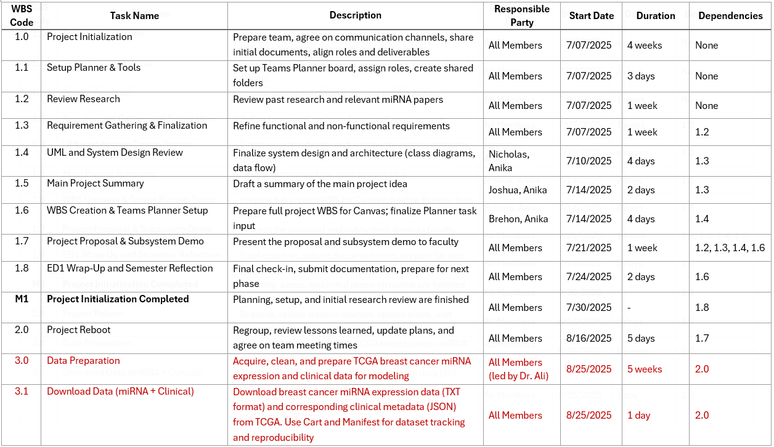
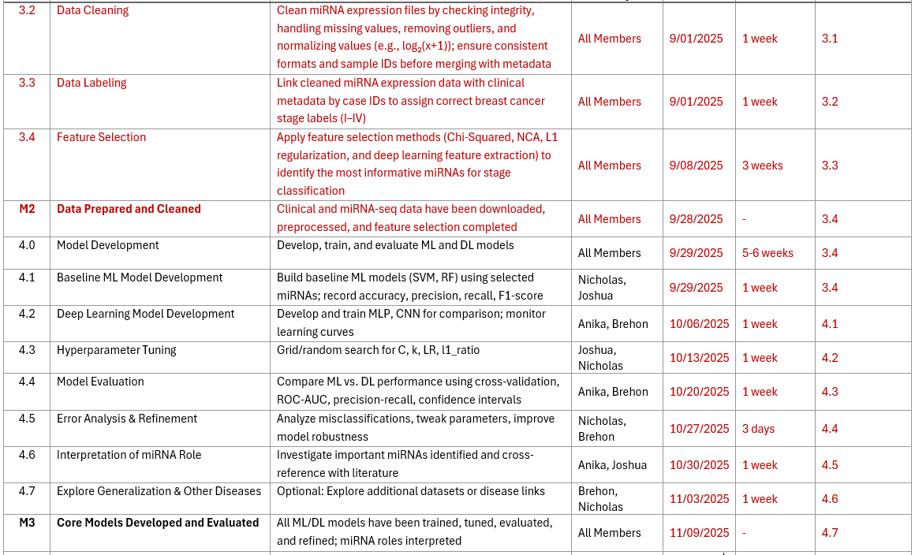

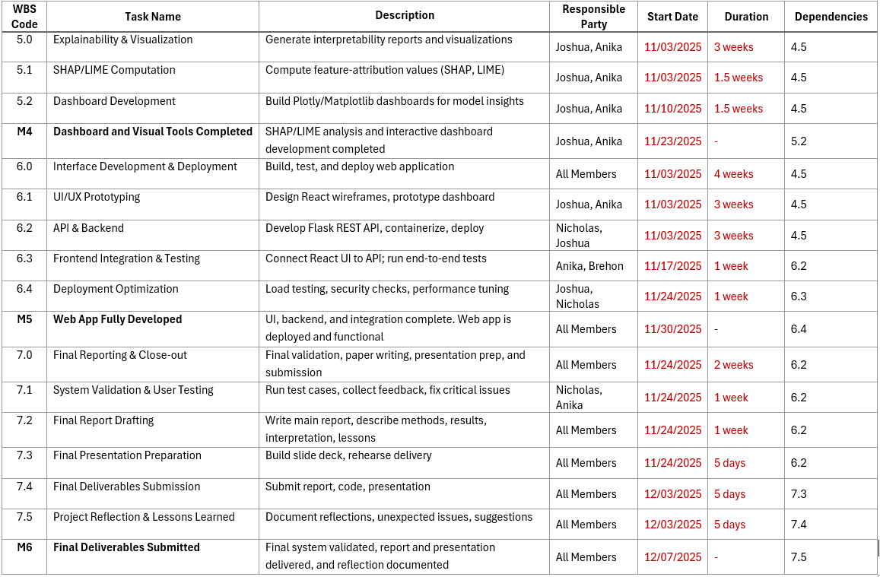
Table 4: Work Breakdown Structure (WBS)

4.3 Summary of Completed Tasks and Sub-Tasks
As of the current milestone, the team has completed all initialization and early-phase project activities outlined in the WBS (see Table 4). The following summarizes the tasks and sub-tasks that have been accomplished:
- Task 1.1 – Setup Planner and Tools
The team established the Microsoft Teams Planner board, created shared folders, and assigned roles and responsibilities. This ensured a clear structure for project coordination and task tracking.
- Task 1.2 – Review Research
A literature review of relevant miRNA studies and breast cancer stage classification methods was conducted. The team gathered and summarized findings from previous works.
- Task 1.3 – Requirement Gathering and Finalization
Functional, non-functional, and safety requirements were defined and refined. These requirements specify system objectives, constraints, and safeguards for patient privacy and unbiased classification.
- Task 1.4 – UML and System Design Review
The team created a UML System Diagram to outline the system architecture and a UML State Diagram to illustrate workflow transitions. These diagrams allowed the team to validate design logic and ensure alignment with requirements, supporting subsystem design and implementation.
- Task 1.5 – Main Project Summary
A project summary document was prepared, consolidating the research background, problem motivation, and the proposed solution for miRNA-based breast cancer stage classification.
- Task 1.6 – WBS Creation and Teams Planner Setup
The complete WBS was developed, detailing task dependencies, responsible parties, and timeframes. This was integrated into Teams Planner for streamlined monitoring.
- Task 1.7 – Project Proposal and Subsystem Demo
The team prepared and presented the formal project proposal. In the presentation, we discussed the function of each subsystem to show how they work together in the complete system design.
- Task 1.8 – ED1 Wrap-Up and Semester Reflection
A final check-in was completed to summarize outcomes, prepare documentation, and reflect on progress during this phase. Feedback received was reviewed to guide the next project stage.
The team has successfully completed Milestone 1: Project Initialization. This includes setup, research review, requirements gathering, and system design. Together, these deliverables establish a solid foundation for the next project phase, ensuring the system is guided by clear objectives, validated designs, and well-defined requirements.

4.4 Detailed Task Breakdown and Member Responsibilities
This section lists the detailed project tasks and sub-tasks assigned to each member of the team. It expands on the Work Breakdown Structure (WBS) by shifting the focus from overall project phases to individual contributions.
Joshua Adegboyo
1. Gather project requirements
1.1. Set up Microsoft Teams Planner, assign roles, and create shared folders
1.2. Review existing research studies on microRNA-based breast cancer stage classification
1.3. Compile functional and non-functional requirements
1.4. Submit the requirements specification document
STATUS: Completed (July 13, 2025)
2. Model and plan the System
2.1. Create system and subsystem diagrams in Unified Modeling Language (UML)
2.2. Review diagrams against the requirements and revise as needed
2.3. Draft project summary document
2.4. Build the work breakdown structure (WBS) with tasks, owners, durations, and dependencies
2.5. Instantiate the WBS in Microsoft Teams Planner

2.6. Submit the project summary, design, and development plan
STATUS: Completed (July 20, 2025)

3. Draft the project proposal and present
3.1. Write the training data subsystem section
3.2. Write the implementation and test plan section
3.3. Submit the project proposal
3.4. Prepare slides and speaker notes for the presentation
3.5. Present the proposal and demonstrate the subsystems
STATUS: Completed (July 27, 2025)

Milestone 1 – Project Initialization Completed – July 30, 2025

4. Download data from GDC Portal
4.1. Configure filters (primary site: breast; experimental strategy: microRNA sequencing; data type: microRNA expression quantification; access: open; tissue: normal and tumor; format: .txt)
4.2. Verify file and case counts (about 1,209 files and 1,081 cases)
4.3. Add files to the cart and export the manifest for tracking
4.4. Download microRNA expression files (.txt) and clinical metadata files (JSON)
STATUS: Completed (August 31, 2025)

5. Clean and label the dataset
5.1. Validate the schemas for the expression files and the clinical JSON files
5.2. Normalize values with a log₂(x+1) transform, handle missing values, and remove obvious outliers
5.3. Harmonize identifiers and map stage labels (I–IV) by case identifier
5.4. Merge expression data with labels and recheck class balance
5.5. Save the cleaned and labeled dataset with versioning
DUE: September 7, 2025

6. Perform feature selection (Chi-squared focus)
6.1. Prepare a split manifest for training, validation, and testing with a fixed random seed
6.2. Apply Chi-squared–based feature selection to derive top-k microRNA panels
6.3. Run a sensitivity analysis over k and document the stability of selected panels
6.4. Export final feature lists and a feature-selection report with code and seeds
DUE: September 14, 2025

Milestone 2 – Data Prepared and Cleaned – September 28, 2025

7. Develop deep learning models
7.1. Build and train a multilayer perceptron and a one-dimensional convolutional neural network; monitor learning curves
7.2 Evaluate with cross-validation and compute standard metrics (accuracy, precision, recall, F1) plus area under the receiver operating characteristic curve and precision–recall metrics
DUE: October 12, 2025

8. Evaluate and compare traditional and deep learning models
8.1. Evaluate once on the 15% held-out test set (no reuse during training)
8.2. Compile a comparison table with accuracy, precision, recall, macro-F1 score, and receiver operating characteristic area under the curve, including seeds and splits used
8.3. Write a summary stating which approach performs better, by how much, and with what caveats
DUE: October 26, 2025

9. Interpret model behavior
9.1. Identify important microRNAs from trained models and cross-reference with relevant literature
9.2. Write a summary explaining the top microRNAs by class, the biological rationale, key caveats, and include citations.
DUE: November 2, 2025

Milestone 3 – Core Models Developed and Evaluated – November 9, 2025

10. Generate explainability outputs and visualizations
10.1. Compute feature attributions using SHAP and LIME
10.2. Build diagnostic charts and dashboards with Plotly and Matplotlib for model insight
10.3. Write a short interpretability note linking features to stages and to prior literature
DUE: November 23, 2025

Milestone 4 – Dashboard and Visual Tools Completed – November 23, 2025

11. Design React wireframes and prototype the dashboard
11.1. Create wireframes for key screens and define required components
11.2. Build a React prototype with routes and placeholders driven by mock data
11.3. Conduct a team review and revise the prototype
DUE: November 16, 2025
12. Integrate frontend and run end-to-end tests
12.1. Connect the React UI to backend API endpoints for prediction and health checking
12.2. Configure CORS for local and containerized deployments
12.3. Define request and response schemas and implement client-side validation for uploaded files
12.4. Run end-to-end smoke tests with sample files; capture logs and screenshots
12.5. Fix critical integration issues, re-test until smoke suite passes
DUE: November 23, 2025

Milestone 5 – Web App Fully Developed — November 30, 2025

13. Validate system and conduct user testing
13.1. Run use-case scenarios from Section 3.2.2: upload, predict, and review results
13.2. Run pilot user tests, capturing feedback and issues
13.3. Fix high-severity defects and re-test affected flows
13.4. Confirm reproducibility in Docker (same input, same output); save version log
DUE: November 30, 2025

14. Finalize final project report and prepare presentation
14.1. Write final report discussing the overall system design and implementation of the project
14.2. Build the slide deck and rehearse delivery
14.3. Submit the report, code, and presentation
14.4. Document reflections, unexpected issues, and lessons learned
DUE: December 7, 2025

Milestone 6 – Final Deliverables Submitted — December 7, 2025

Anika Baro Villa
1. Gather project requirements
1.1. Set up Microsoft Teams Planner, assign roles, and create shared folders
1.2. Review existing research studies on microRNA-based breast cancer stage classification
1.3. Compile functional and non-functional requirements
1.4. Submit the requirements specification document
STATUS: Completed (July 13, 2025)

2. Model and plan the System
2.1. Create system and subsystem diagrams in Unified Modeling Language (UML)
2.2. Review diagrams against the requirements and revise as needed
2.3. Draft project summary document
2.4. Build the work breakdown structure (WBS) with tasks, owners, durations, and dependencies
2.5. Instantiate the WBS in Microsoft Teams Planner
2.6. Submit the project summary, design, and development plan
STATUS: Completed (July 20, 2025)

3. Draft the project proposal and present
3.1. Write the training data subsystem section
3.2. Write the implementation and test plan section
3.3. Submit the project proposal
3.4. Prepare slides and speaker notes for the presentation
3.5. Present the proposal and demonstrate the subsystems
STATUS: Completed (July 27, 2025)

Milestone 1 – Project Initialization Completed – July 30, 2025
4. Download data from GDC Portal
4.1. Configure filters (primary site: breast; experimental strategy: microRNA sequencing; data type: microRNA expression quantification; access: open; tissue: normal and tumor; format: .txt)
4.2. Verify file and case counts (about 1,209 files and 1,081 cases)
4.3. Add files to the cart and export the manifest for tracking
4.4. Download microRNA expression files (.txt) and clinical metadata files (JSON)
STATUS: Completed (August 31, 2025)

5. Clean and label the dataset
5.1. Validate the schemas for the expression files and the clinical JSON files
5.2. Normalize values with a log₂(x+1) transform, handle missing values, and remove obvious outliers
5.3. Harmonize identifiers and map stage labels (I–IV) by case identifier
5.4. Merge expression data with labels and recheck class balance
5.5. Save the cleaned and labeled dataset with versioning
DUE: September 7, 2025

6. Perform feature selection (lasso focus)
6.1. Prepare a split manifest for training, validation, and testing with a fixed random seed
6.2. Apply lasso regularization–based feature selection to derive top-k microRNA panels
6.3. Run a sensitivity analysis over k and document the stability of selected panels
6.4. Export final feature lists and a feature-selection report with code and seeds
DUE: September 14, 2025

Milestone 2 – Data Prepared and Cleaned – September 28, 2025

7. Develop deep learning models
7.1. Build and train a multilayer perceptron and a one-dimensional convolutional neural network; monitor learning curves
7.2 Evaluate with cross-validation and compute standard metrics (accuracy, precision, recall, F1) plus area under the receiver operating characteristic curve and precision–recall metrics
DUE: October 12, 2025

8. Evaluate and compare traditional and deep learning models
8.1. Evaluate once on the 15% held-out test set (no reuse during training)
8.2. Compile a comparison table with accuracy, precision, recall, macro-F1 score, and receiver operating characteristic area under the curve, including seeds and splits used
8.3. Write a summary stating which approach performs better, by how much, and with what caveats
DUE: October 26, 2025
9. Interpret model behavior
9.1. Identify important microRNAs from trained models and cross-reference with relevant literature
9.2. Write a summary explaining the top microRNAs by class, the biological rationale, key caveats, and include citations.
DUE: November 2, 2025

Milestone 3 – Core Models Developed and Evaluated – November 9, 2025

10. Generate explainability outputs and visualizations
10.1. Compute feature attributions using SHAP and LIME
10.2. Build diagnostic charts and dashboards with Plotly and Matplotlib for model insight
10.3. Write a short interpretability note linking features to stages and to prior literature
DUE: November 23, 2025

Milestone 4 – Dashboard and Visual Tools Completed – November 23, 2025

11. Design React wireframes and prototype the dashboard
11.1. Create wireframes for key screens and define required components
11.2. Build a React prototype with routes and placeholders driven by mock data
11.3. Conduct a team review and revise the prototype
DUE: November 16, 2025
12. Integrate frontend and run end-to-end tests
12.1. Connect the React UI to backend API endpoints for prediction and health checking
12.2. Configure CORS for local and containerized deployments
12.3. Define request and response schemas and implement client-side validation for uploaded files
12.4. Run end-to-end smoke tests with sample files; capture logs and screenshots
12.5. Fix critical integration issues; re-test until smoke suite passes
DUE: November 23, 2025

Milestone 5 – Web App Fully Developed — November 30, 2025

13. Validate system and conduct user testing
13.1. Run use-case scenarios from Section 3.2.2: upload, predict, and review results
13.2. Run pilot user tests, capturing feedback and issues
13.3. Fix high-severity defects and re-test affected flows
13.4. Confirm reproducibility in Docker (same input, same output); save version log
DUE: November 30, 2025

14. Finalize final project report and prepare presentation
14.1. Write final report discussing the overall system design and implementation of the project
14.2. Build the slide deck and rehearse delivery
14.3. Submit the report, code, and presentation

14.4. Document reflections, unexpected issues, and lessons learned
DUE: December 7, 2025

Milestone 6 – Final Deliverables Submitted — December 7, 2025

Nicholas Campos
1. Gather project requirements
1.1. Set up Microsoft Teams Planner, assign roles, and create shared folders
1.2. Review existing research studies on microRNA-based breast cancer stage classification
1.3. Compile functional and non-functional requirements
1.4. Submit the requirements specification document
STATUS: Completed (July 13, 2025)

2. Model and plan the System
2.1. Create system and subsystem diagrams in Unified Modeling Language (UML)
2.2. Review diagrams against the requirements and revise as needed 2.3. Draft project summary document
2.3. Build the work breakdown structure (WBS) with tasks, owners, durations, and dependencies
2.4. Instantiate the WBS in Microsoft Teams Planner
2.5. Submit the project summary, design, and development plan
STATUS: Completed (July 20, 2025)

3. Draft the project proposal and present
3.1. Write the model subsystem section
3.2. Write the implementation and test plan section
3.3. Submit the project proposal
3.4. Prepare slides and speaker notes for the presentation
3.5. Present the proposal and demonstrate the subsystems
STATUS: Completed (July 27, 2025)

Milestone 1 – Project Initialization Completed – July 30, 2025
4. Download data from GDC Portal
4.1. Configure filters (primary site: breast; experimental strategy: microRNA sequencing; data type: microRNA expression quantification; access: open; tissue: normal and tumor; format: .txt)
4.2. Verify file and case counts (about 1,209 files and 1,081 cases)
4.3. Add files to the cart and export the manifest for tracking
4.4. Download microRNA expression files (.txt) and clinical metadata files (JSON)
STATUS: Completed (August 31, 2025)

5. Clean and label the dataset
5.1. Validate the schemas for the expression files and the clinical JSON files
5.2. Normalize values with a log₂(x+1) transform, handle missing values, and remove obvious outliers
5.3. Harmonize identifiers and map stage labels (I–IV) by case identifier
5.4. Merge expression data with labels and recheck class balance
5.5. Save the cleaned and labeled dataset with versioning
DUE: September 7, 2025
6. Perform feature selection (mutual information focus)
6.1. Prepare a split manifest for training, validation, and testing with a fixed random seed
6.2. Apply mutual information–based feature selection to derive top-k microRNA panels
6.3. Run a sensitivity analysis over k and document the stability of selected panels
6.4. Export final feature lists and a feature-selection report with code and seeds
DUE: September 14, 2025

Milestone 2 – Data Prepared and Cleaned – September 28, 2025
7. Develop baseline ML models
7.1. Build and train Support Vector Machine and Random Forest classifiers using selected microRNA features
7.2. Evaluate with cross-validation and compute standard metrics (accuracy, precision, recall, F1) plus area under the receiver operating characteristic curve and precision-recall metrics
DUE: October 5, 2025

8. Develop deep learning models
8.1. Build and train a multilayer perceptron and a one-dimensional convolutional neural network; monitor learning curves
8.2. Evaluate with cross-validation and compute standard metrics (accuracy, precision, recall, F1) plus area under the receiver operating characteristic curve and precision-recall metrics
DUE: October 12, 2025

9. Evaluate and compare traditional and deep learning models
9.1. Evaluate once on the 15% held-out test set (no reuse during training)
9.2. Compile a comparison table with accuracy, precision, recall, macro-F1 score, and receiver operating characteristic area under the curve, including seeds and splits used
9.3. Write a summary stating which approach performs better, by how much, and with what caveats
DUE: October 26, 2025

Milestone 3 – Core Models Developed and Evaluated – November 9, 2025
10. Generate model performance visualizations
10.1. Create confusion matrices and ROC curves for both ML and DL approaches
10.2. Build performance comparison charts and learning curve visualizations
10.3. Document model architecture details and hyperparameter optimization results
DUE: November 16, 2025

11. Develop Flask API backend
11.1. Create RESTful endpoints for model predictions and health checking
11.2. Implement request/response validation and error handling
11.3. Configure CORS and containerization for deployment
DUE: November 23, 2025

Milestone 4 – Dashboard and Visual Tools Completed – November 23, 2025
12. Integrate frontend and run end-to-end tests
12.1. Connect the React UI to backend API endpoints for prediction and health checking
12.2. Configure CORS for local and containerized deployments
12.3. Define request and response schemas and implement client-side validation for uploaded files
12.4. Run end-to-end smoke tests with sample files; capture logs and screenshots
12.5. Fix critical integration issues; re-test until smoke suite passes
DUE: November 23, 2025

Milestone 5 – Web App Fully Developed — November 30, 2025

13. Validate system and conduct user testing
13.1. Run use-case scenarios from Section 3.2.2: upload, predict, and review results 13.2. Run pilot user tests, capturing feedback and issues
13.3. Fix high-severity defects and re-test affected flows
13.4. Confirm reproducibility in Docker (same input, same output); save version log
DUE: November 30, 2025

14. Finalize final project report and prepare presentation
14.1. Write final report discussing the overall system design and implementation of the project
14.2. Build the slide deck and rehearse delivery
14.3. Submit the report, code, and presentation
14.4. Document reflections, unexpected issues, and lessons learned
DUE: December 7, 2025

Milestone 6 – Final Deliverables Submitted — December 7, 2025

Brehon Parker
1. Gather project requirements
1.1. Set up Microsoft Teams Planner, assign roles, and create shared folders
1.2. Review existing research studies on microRNA-based breast cancer stage classification
1.3. Compile functional and non-functional requirements
1.4. Submit the requirements specification document
STATUS: Completed (July 13, 2025)

2. Model and plan the system
2.4. Build the work breakdown structure (WBS) with tasks, owners, durations, and dependencies
2.5. Instantiate the WBS in Microsoft Teams Planner
STATUS: Completed (July 20, 2025)

3. Draft the project proposal and present
3.3. Submit the project proposal
3.4. Prepare slides and speaker notes for the presentation
3.5. Present the proposal and demonstrate the subsystems
STATUS: Completed (July 27, 2025)

Milestone 1 – Project Initialization Completed – July 30, 2025

4. Download data from GDC Portal
4.1. Configure filters (primary site: breast; experimental strategy: microRNA sequencing; data type: microRNA expression quantification; access: open; tissue: normal and tumor; format: .txt)
4.2. Verify file and case counts (about 1,209 files and 1,081 cases)
4.3. Add files to the cart and export the manifest for tracking
4.4. Download microRNA expression files (.txt) and clinical metadata files (JSON)
STATUS: Completed (August 25, 2025)

5. Clean and label the dataset
5.1. Validate the schemas for the expression files and the clinical JSON files
5.2. Normalize values with a log₂(x+1) transform, handle missing values, and remove obvious outliers
5.3. Harmonize identifiers and map stage labels (I–IV) by case identifier
5.4. Merge expression data with labels and recheck class balance
5.5. Save the cleaned and labeled dataset with versioning
DUE: September 7, 2025

6. Perform feature selection (lasso focus
6.1. Prepare a split manifest for training, validation, and testing with a fixed random seed
6.2. Apply lasso regularization–based feature selection to derive top-k microRNA panels
6.3. Run a sensitivity analysis over k and document the stability of selected panels
6.4. Export final feature lists and a feature-selection report with code and seeds
DUE: September 14, 2025

Milestone 2 – Data Prepared and Cleaned – September 28, 2025

7. Develop deep learning model
7.1. Build and train a multilayer perceptron and a one-dimensional convolutional neural network; monitor learning curves
7.2. Evaluate with cross-validation and compute standard metrics (accuracy, precision, recall, F1) plus area under the receiver operating characteristic curve and precision–recall metrics
DUE: October 12, 2025

8. Evaluate and compare traditional and deep learning models
8.1. Evaluate once on the 15% held-out test set (no reuse during training)
8.2. Compile a comparison table with accuracy, precision, recall, macro-F1 score, and receiver operating characteristic area under the curve, including seeds and splits used

8.3. Write a summary stating which approach performs better, by how much, and with what caveats
DUE: October 26, 2025

Milestone 3 – Core Models Developed and Evaluated – November 9, 2025

12. Integrate frontend and run end-to-end tests
12.1. Connect the React UI to backend API endpoints for prediction and health checking
12.2. Configure CORS for local and containerized deployments
12.3. Define request and response schemas and implement client-side validation for uploaded files
12.4. Run end-to-end smoke tests with sample files; capture logs and screenshots
12.5. Fix critical integration issues; re-test until smoke suite passes
DUE: November 23, 2025

Milestone 5 – Web App Fully Developed — November 30, 2025

14. Finalize final project report and prepare presentation
14.1. Write final report discussing the overall system design and implementation of the project
14.2. Build the slide deck and rehearse delivery
14.3. Submit the report, code, and presentation
14.4. Document reflections, unexpected issues, and lessons learned
DUE: December 7, 2025

Milestone 6 – Final Deliverables Submitted — December 7, 2025

4.5 Organizational Chart
Figure 7 illustrates the organization of our team, including the team leader, project manager, and other members. It also highlights each member’s role in keeping the project on track and ensuring that responsibilities are clearly divided.
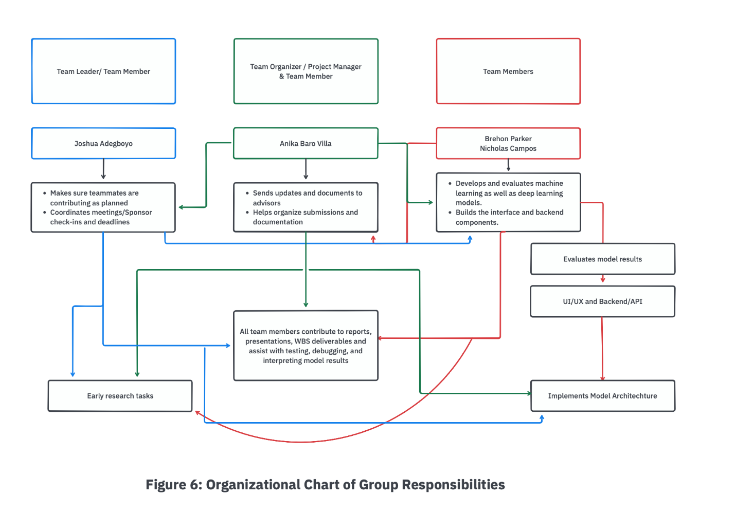
Figure 7: Organizational Chart of Group Responsibilities

4.5 Budget
Our project does not require any physical purchases. All tools and platforms utilized in this project are either open-source, free for academic use, or available through existing educational licenses (e.g., Microsoft Teams, Google Docs, GitHub Student Pack). As such, no budget is required.

References
- Zhang, Y., Yang, Y., & Wang, J. (2019). Identification of stage-specific breast cancer-related microRNAs using support vector machines. Journal of Cellular Biochemistry, 120(8), 12920–12928. https://doi.org/10.1002/jcb.28537
- Peng, L., Chu, H., Wang, M., & Liao, Y. (2020). Random forest-based classification of breast cancer using microRNA profiles. PLOS ONE, 15(3), e0230426. https://doi.org/10.1371/journal.pone.0230426
- Li, Y., Li, Y., Wang, H., & Zhang, H. (2020). Deep learning for breast cancer classification based on miRNA expression data. Frontiers in Genetics, 11, 1120. https://doi.org/10.3389/fgene.2020.01120
- X. Liu, Y. Guo, and X. Zhang, “Deep learning for cancer stage classification using gene expression heatmaps,” IEEE Access, vol. 9, pp. 98612–98622, 2021. [Online]. Available: https://doi.org/10.1109/ACCESS.2021.3096312
- U.S. Food and Drug Administration. (2021). Proposed regulatory framework for modifications to artificial intelligence/machine learning-based software as a medical device (SaMD) — Discussion paper and request for feedback. U.S. Food and Drug Administration. https://www.fda.gov/media/122535/download

